**CSE 306**

**TD 01**

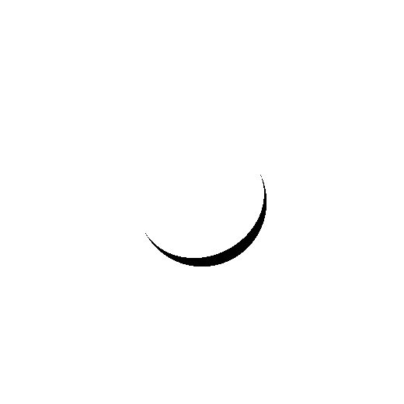

First sphere with intensity = 10^10

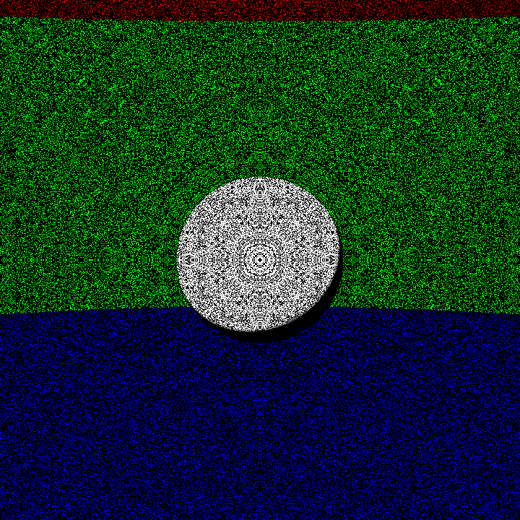

Noisy sphere

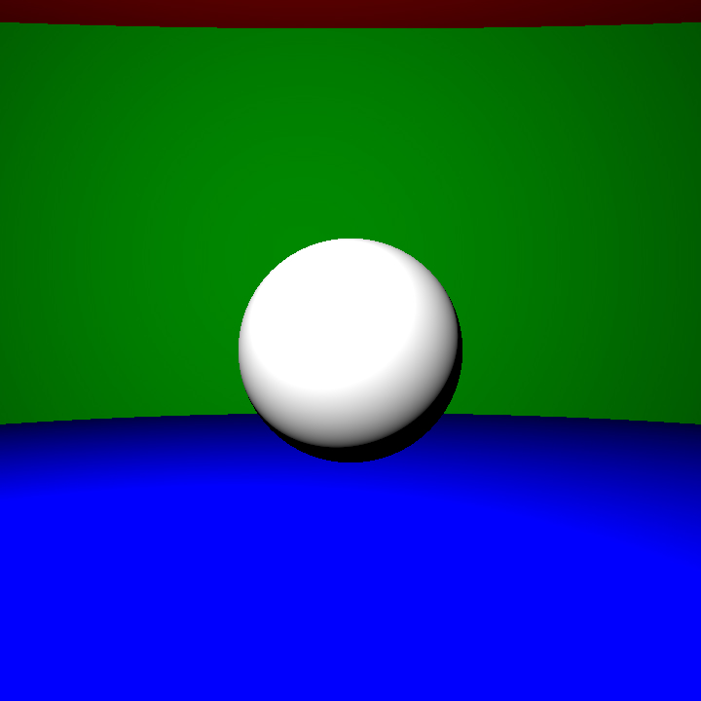

Denoise sphere with offset + gamma correction

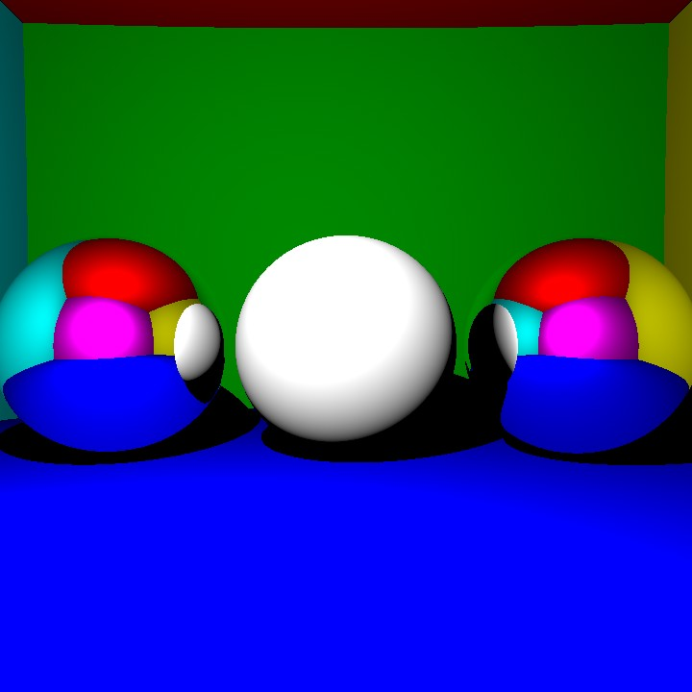

Spheres with shadows and mirrors

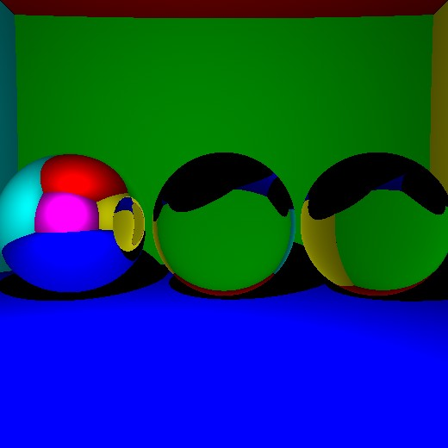

With refraction

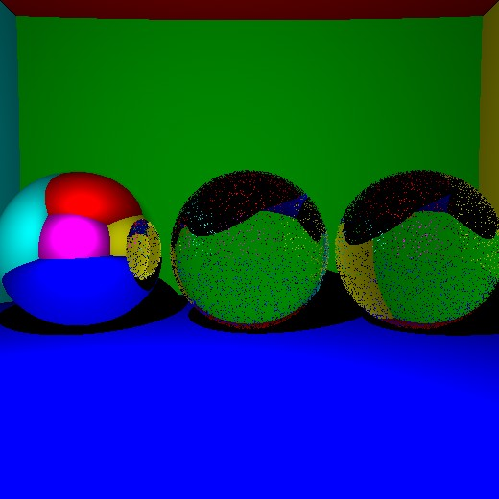

With Fresnel law

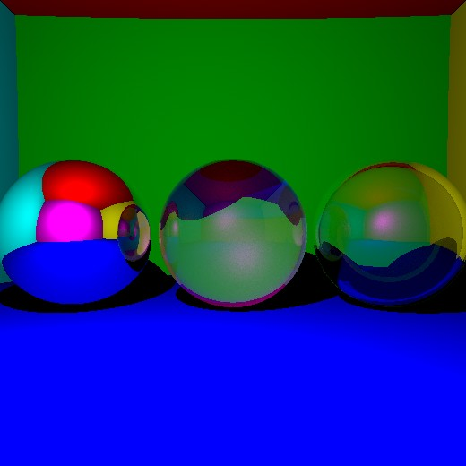

Clean Fresnel reflection with K = 1000 and taking about 54 seconds to run + try to do the hollow sphere (which doesn’t really work)

**TD 02**

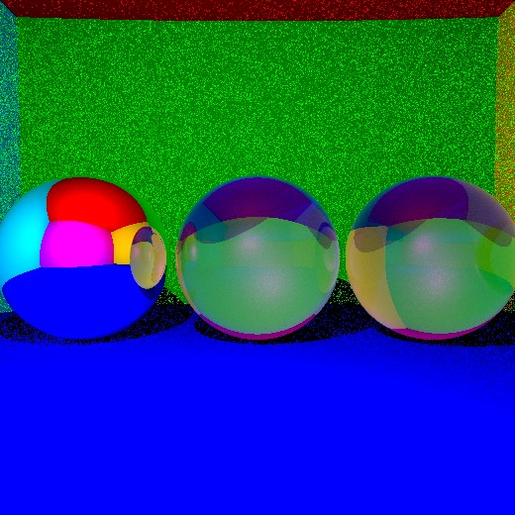

Indirect lighting (only on the transparent spheres, thus the noise on the walls)

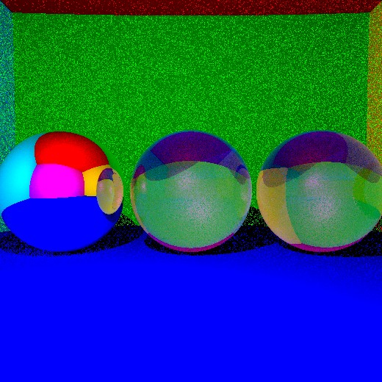

With parallelization (K = 100, 33 seconds)

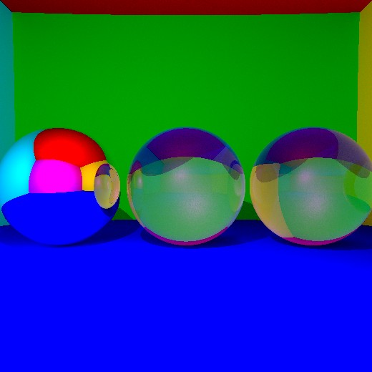

K = 1000, 260 seconds

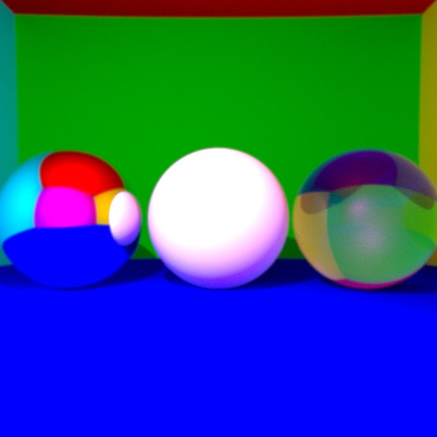

Antialiasing (K = 1000)

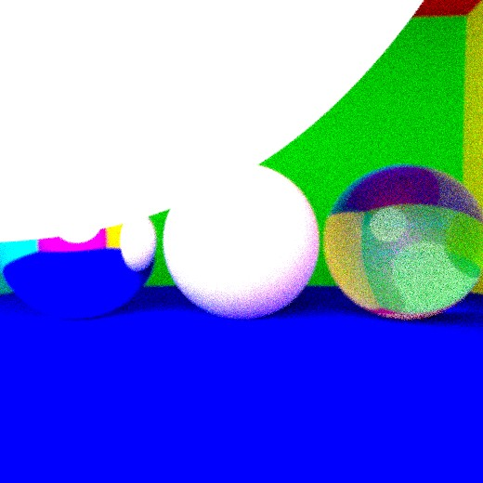

Soft shadow, K = 100 and radius of the light = 20

I think the soft shadow is working. However, it made the image noisier and took more time to run so I decided to use a point light source.

I then tried to reorganize all my files (see before clean commit) but I didn’t manage to get ride of a bug.

I still implemented the Ray-Triangle intersection though no way of checking if it works correctly.